Bishopsteignton Primary School
Cockhaven Close
Bishopsteignton
Teignmouth
TQ14 9RJ
01626 775873
Email: admin@bishopschool.co.uk
Website: www.bishopsteignton.devon.sch.uk/

Believe in ourselves; be the best we can be
Newsletter 01.07.22
Staffing Update - Primary School
Laura Thomas who has been teaching in the Investigators has accepted a role for September at Kingsteignton Primary School in an upper Key Stage 2 class, which will offer her a new challenge. Miss Thomas has been at our school for 5 years now and will be greatly missed by children and staff. We wish her all the very best for the future!
After interviewing last week, we have appointed Charlotte Wintle to join our KS1 teaching team in September. Miss Wintle is an experienced KS1 teacher and we are really looking forward to welcoming her to the school.
Reports and Report Updates - Primary School
On Monday 11th July, we will be sending home end of year reports for children in Explorers; children in all other classes will receive their Summer Report Updates, which will give an overview of end of term assessments.
Along with reports, you will also find details of your child’s class and teacher for the next year, along with a Welcome Booklet for you to share with your child to support their transition into the next school year.
Transition Days - Primary School
(separate information has been sent out for our new Explorers!)
- Tuesday 19th July (morning only)
- Thursday 21st July (morning and afternoon session)
On these days, children will visit their new classes from 9.15. Drop off will be as normal in the children’s current classes.
When we reviewed our transition process a few years ago, the children told us that they wanted to experience what their day was likely to be like in September, rather than just do ‘fun’ things! The teachers have considered this when planning their activities, and children will follow the timings of their new class.
On Thursday 21st July, we ask that children are collected from their new classrooms, where you will have the opportunity to meet their new teacher. Please check with your child’s current teacher or the office if you aren’t sure where the classroom is and they will be happy to help!

Sports Day
Thank you for all your support with our KS1 and KS2 Sports Days last week. The new format proved to be a success with the children who enjoyed fully participating in the carousel of activities. Our Y6 House Captains did a fantastic job of supporting children in their house teams. We’d like to thank Mr Jeffery for making the events such a success and also say a big thank you to Tim Flint and David Palmer from Dynamic Sports for organising the activities. The results from the Sports Day were revealed to the children on Tuesday. A huge well done to Exe, who were our winners this year!
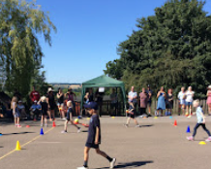
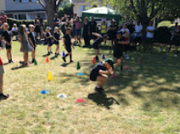
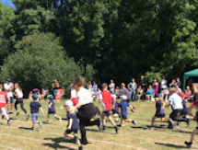
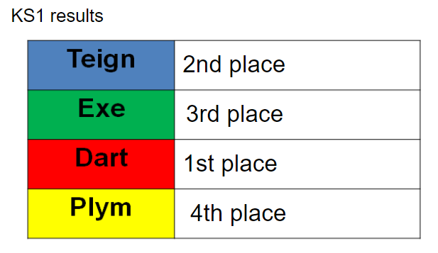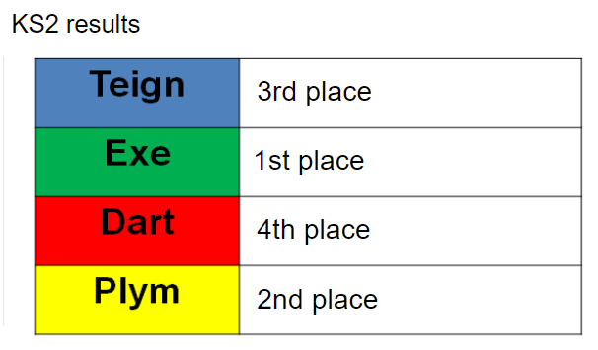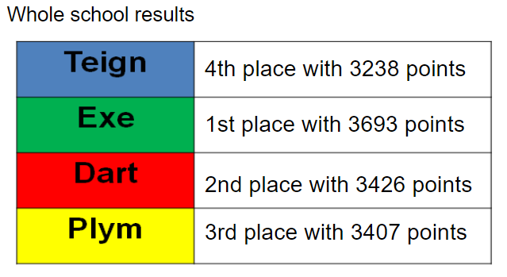

Beach Clean
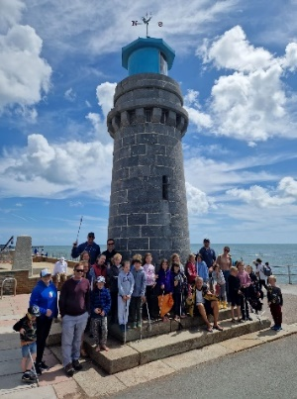
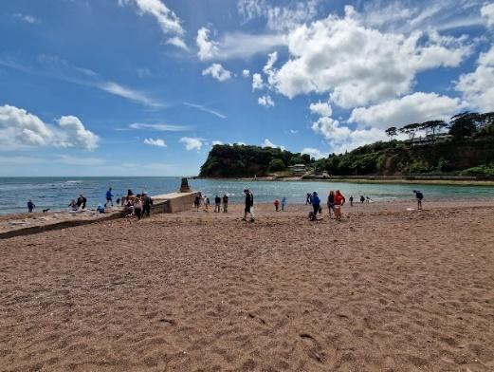
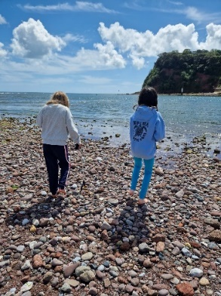
Following topic work about the environmental impact plastic pollution has on animals, the Year 3/4 children were inspired to carry out their own beach clean and wrote a persuasive letter to their parents inviting them to join in. It was amazing to see so many children and parents taking time out of their Sunday to join in the beach clean alongside ‘Teignmouth Beach Clean’ group. We even got a feature in this week’s newspaper! Thank you to all those who took part.

“It was really fun because you’re helping the environment and it was really interesting to see what rubbish people leave on the beach!” Chloe – Y4
We hope you are able to join us and support the Summer Fair this afternoon which is helping to raise important funds for the school and preschool.
Many thanks for your continued support
Emma Leballeur, Deputy Headteacher
FUTURE DATES FOR THE PRIMARY SCHOOL
Mon 11th July | Explorers Reports  Summer Report Updates for Y1-Y6
Tues 12th and  Thurs 14th July | Parent Teacher Meetings (Y1-Y6)
Fri 15th July | Y6 Leavers Assembly followed by Leavers BBQ
Tues 19th July  Thurs 21st July | Transition in new classes
Thurs 21st July | ‘Meet the Teacher’ in new classes after school
Fri 22nd July | Y6 ‘Ring the Bell’ (a Bishop tradition!)
Fri 22nd July | Last Day of Term

