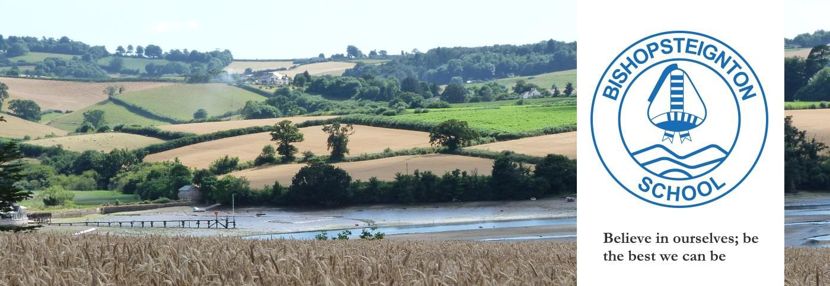

December 2023
As winter gets underway, we’re winding up our first term of the 2023/24 year. It’s an incredibly busy time of year with lots of festive activities to look forward to both in school and in the wider community. A huge thank you to all the staff, the children and the myriad of lovely volunteers in our school community who work so hard to make the concerts, performances and other events such joyous and happy occasions at this special time.
At the end of the summer, we said farewell to Faye Robertson, a long -standing parent governor who has been an invaluable and highly regarded member of our Governing Board for many years. We wish her well and continued success in all her new ventures and would like to thank her for all her support and considerable expertise in the development of our Mathematics curriculum over the years. We are pleased to share with you some information about Jonathan Watson, our newest governor and member of the Resources committee.
Jonathan is a parent governor who originally hails from the Midlands but has lived in the village with his wife since 2017. Prior to joining the governing board, he served as a Parish Counsellor for over 3 years but has always been determined to play an active school role once his son joined Bishop. Jonathan’s professional background as a business intelligence manager brings a wealth of skills and experience that will be an appreciated and valuable asset to the Board of Governors and consequently to the school and its children.
If you want to find out more about any of the other Governors please visit the school website, “Our Community - Governors” page for more details.
Governor Activity
As Governors, we are responsible for overseeing the management side of the school: strategy, policy, budgeting and staffing. We help to enable the school to run as effectively as possible, working alongside the senior leaders and supporting the teachers to provide excellent education to all the children at Bishop. We are also involved in the school community, acting as critical friends to the Headteacher and senior leaders. Our Governing Board brings a wide range of skills and expertise from our professional lives, and we give up our time freely to attend regular committee meetings, full governing board meetings and to make focused visits in order to learn more about how the school is performing and help us to support the school to be the best it can be.

Governor Visits
Governors regularly make formal visits to the school. These allow us to see the school ‘in action,’ enabling us to see how things are going with reference to the whole school development plan and help us to understand better the challenges and opportunities that arise as the academic year progresses.

Sonya Lamoon (our Early Years Governor) has visited the Preschool once again. This time, she discussed the planning an implementation of Phase 1 Phonics with Lyn Jolly, Emma Leballeur and Christie Tribble. Sonya met with teaching staff to discuss how early Phonics is being implemented and talked about ways in which these very early speaking and listening phonic skills can be used to support the development of Phonics as the children move on up into Reception. She was pleased to see how the early listening and ‘tuning into sounds’ activities are being detailed in the planning and support the children’s learning. Sonya will plan another visit in the Spring Term to see how this work is being developed as the children become more confident in their phonic knowledge and skills.

Pauline Morley (our SEND lead) caught up with Maeve Kay, our SENDCO to understand the excellent processes and procedures that have put in place in her time at Bishop. Unfortunately, Maeve is leaving our school at the end of this term and we wish her the best in her new endeavors. This meeting and further discussions will ensure a smooth hand over to her replacement with minimal interruption for our SEND pupils and their learning.

FOBS – Friends of Bishopsteignton School

This October, FOBS reinstated their much- appreciated monthly cake sale, and organised the fabulous school discos. Soon you will be able to purchase cut price pantomime tickets for Beauty and the Beast at the Princess Theatre in Torquay throughout December – in doing so you will also be helping to raise money for FOBS – keep an eye out for the FOBS newsletter for more details!
FOBS is run entirely by parent/carer volunteers and without their efforts many of the events just wouldn’t be able to go ahead, so if you can offer a couple of hours a year to help out at an event, please get in touch with a member of FOBS or contact the school office. They will be very pleased to have your support! Last year this marvelous team of lovely people raised funds which enabled the school to continue to run the forest school sessions, purchased gazebos, a playground buddy bench and the new playground markings – just a few of the much needed resources which help to make our school such a wonderful place to be.
There are also some important committee members leaving over the next few months, so if you would like to be involved, the Chair, Vice-Chair and Secretary positions are all available! As always, the Governing Board and whole school are very grateful for their continuing support and we hope the whole community can assist them in whatever way they can going forward into the new year.
Pupil Numbers
Our school and many others in the local area are facing reduced pupil numbers due to a falling birth rate. This comes with its challenges in terms of our school budget, resources and staffing so finally this is just a brief reminder that the whole school community would greatly benefit from you sharing all that goes on here with other parents who may be looking for school and perhaps hadn’t considered us! The fabulous updates on the school Facebook page help to keep us all informed and can be shared far and wide with friends and family.

We would like to thank all the staff for a great start to the new school year. Wrap up warm and enjoy the holidays – we look forward to seeing you all in January. Have a wonderful Christmas and very happy New Year!

From all of us on the Bishopsteignton Governing Board

Governor contacts:
Should you wish to contact the Governing Board then please email our Chair of Governors :
Dave Boobyer- chair@bishopschool.co.uk
or our Clerk to Governors: Geoff Jones - clerk1@bishopschool.co.uk

SCHOOL GOVERNORS
CHAIR OF GOVERNORS: Dave Boobyer, Co-opted LOCAL AUTHORITY GOVERNOR: Graham Hooker
CO-OPTED GOVERNORS: David Lamboll | James Kilby | Pauline Morley | Sonya Lamoon PARENT GOVERNORS: Paul Zaleski | | Jonathan Watson | Chris Merritt | Nick Long
STAFF: Emma Leballeur (Staff Governor) Dave Killoran (Headteacher) | Geoff Jones (Clerk)

